
Title: a Concise and Characteristic Description of the
Involved Research Content
Family name First name¹,Family name First name¹and
First name Middle name Family name²
Received 【October 17】, 2026
Accepted 【November 29】, 2026
© Jilin University, The Editorial Depart-ment of Chemical Research in Chinese Universities and Springer-Verlag GmbH
【NOTE: The family name needs to be written in all capital letters.】

T????????????????????????? ??????????????????????? ??????????????????????? ??????????????????????? ?????????????????????????????????????????????? ????????????????????????? ??????????????????????? ??????????????????????? ??????????????????????? ????????????????????????????????????????????? ????????????????????????? ??????????????????????? ??????????????????????? ??????????????????????? ?????????????????????????????????????????????
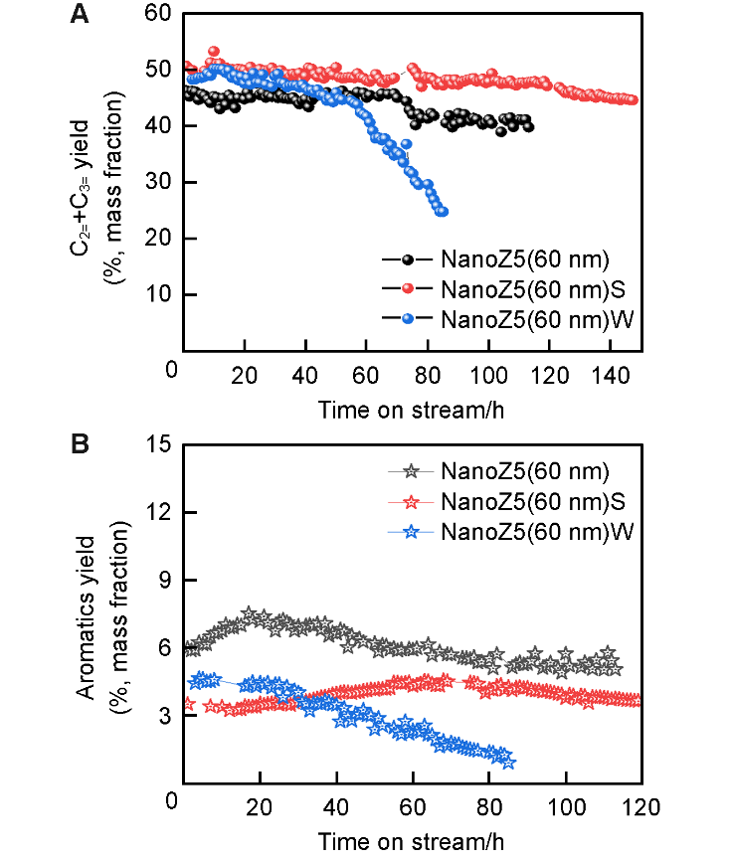
????????????????????????? ??????????????????????? ??????????????????????? ??????????????????????? ?????????????????????????????????????????????? ????????????????????????? ??????????????????????? ??????????????????????? ??????????????????????? ??????????????????????? ?????????????????????????????????????????????

XXXXXXX
xxxxx@xxxxxx
1. xxxxxxxxxxxxxxxxxxxxxxxxxxxxxxxxxxxx, P. R. China;
2. xxxxxxxxxxxxxxxxxxxxxxxxxxxxxxxxxxxx, P. R. China

Fig.1 XXXXXXXXXXXXXXXXXXXXXXXX
?????????????????????????
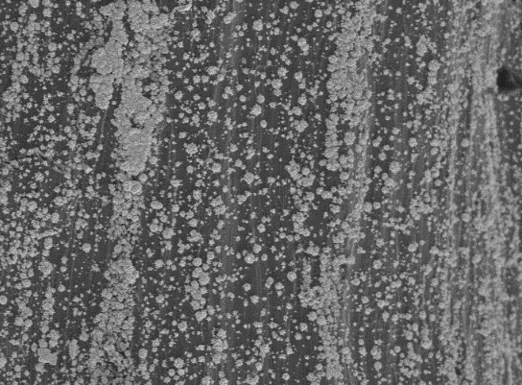
Pt_{1200s}/Ti
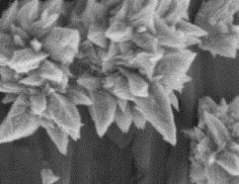
A
10.0 μm

10.0 μm

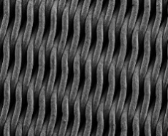
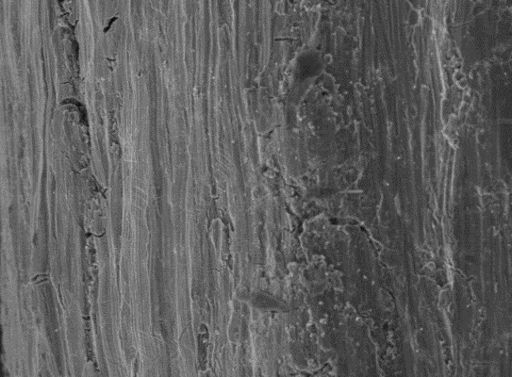
B
Pt_{1400s}/Ti

10.0 μm

10.0 μm

Fig.2 XXXXXXXXXXXXXXXXXXXXXXXX
【Note: The figures should have resolution not lower than 400 dpi (RGB)and clear lines of 3 px, with signs and letters in BoldArial at 7 pt(JPG or TIF format).The text and images should preferably be in editable format (with text boxes inserted) to facilitate later text editing.】

????????????????????????? ??????????????????????? ??????????????????????? ??????????????????????? ?????????????????????????????????????????????? ????????????????????????? ??????????????????????? ??????????????????????? ??????????????????????? ????????????????????????????????????????????? ????????????????????????? ??????????????????????? ??????????????????????? ??????????????????????? ????????????????????????????????????????????? ????????????????????????? ??????????????????????? ??????????????????????? ??????????????????????? ?????????????????????????????????????????????? ????????????????????????? ??????????????????????? ??????????????????????? ??????????????????????? ????????????????????????????????????????????? ????????????????????????? ??????????????????????? ??????????????????????? ??????????????????????? ?????????????????????????????????????????????

Table 1 xxxxxxxxxxxxxxxxxxxxxxxxxxxxxxxxxxxxxx
xxxxxx | Mª/(mol·L^{–1}) | V ^{b}/cm³ | Ref.
 |  |  | [2]
 |  |  | [8]
 |  |  | [11]
a. xxxxxxxxxxxxxxx; b. xxxxxxxxxxxxxxxxxxxxxxxxx.

?? ??????????????????????? ??????????????????????? ?????????????????????????????????????????????? ????????????????????????? ??????????????????????? ??????????????????????? ??????????????????????? ????????????????????????????????????????????? ????????????????????????? ??????????????????????? ??????????????????????? ??????????????????????? ?????????????????????????????????????????????

Supporting Information
The detailed experimental procedures and the supplementary materials are available in the online version of this article at http://dx.doi.org/10.1007/s40242-026-6xxx-x.

Acknowledgements
This work was supported bythe ??????? (No.?????????).

Conflicts of Interest
The authors declare no conflicts of interest.

References
- (Example for Journal) Chae H. G., Kumar S., Science, 2008, 319, 908.
- (Example for Books) Kelly A., Macmillan N. H., Strong Solids, Oxford University Press, New York, 1986.
- (Example for Conference proceedings) Mangano C., Mangano F., Proceedings of the 2nd International Dental Conference on Future Trend in Implantology (FTI), Florence, Italy, 2011.
- (Example for Dissertation) Liu G. X., Classification of finite dimensional basic Hopf algebras and related topics. Dissertation for the Doctoral Degree, Hangzhou University, Hangzhou, 2005, 24.
- (Example for Patent) Zhang H. X., Wang J. J., Ma J., Zhuang H. L., Ao Y. H., Wang H. J., Zhou B. Q., Preparation of Polymer for Polyacrylonitrile-based Carbon Fiber Precursor, CN100564413, 2007.
- (Example for User manual) Wang D. L., Zhu J., Li Z. K., User Manual for QTKMapper Version1.6, 1999.
- (Example for Software) Frisch M. J., Trucks G. W., Schlegel H. B., Scuseria G. E., Robb M. A., Cheeseman J. R., Scalmani G., Barone V., Mennucci B., Petersson G. A., Nakatsuji H., Caricato M., Li X., Hratchian H .P., Izmaylov A. F., Bloino J., Zheng G., Sonnenberg J. L., Hada M., Ehara M., Toyota K., Fox D. J., Gaussian 09 (Revision A.02), Gaussian, Inc., Wallingford CT, 2009.
- (Example for Website) http://www.ccin.com.cn/ccin/news/2011/06/ 07/182521.shtml, accessed on 2011-09-26.

